React errors

1. Uncaught runtime errors: × ERROR Cannot access '__WEBPACK_DEFAULT_EXPORT__' before initialization ReferenceError: Cannot access '__WEBPACK_DEFAULT_EXPORT__' before initialization at Module.default (http://localhost:3000/static/js/bundle.js:975:42) at ./src/Daily_HomeWork/Day8WithOutUseContext/RailwayStation.jsx (http://localhost:3000/static/js/bundle.js:1171:122) at options.factory (http://localhost:3000/static/js/bundle.js:42992:31) at __webpack_require__ (http://localhost:3000/static/js/bundle.js:42443:32) at fn (http://localhost:3000/static/js/bundle.js:42650:21) at ./src/Daily_HomeWork/Day8WithOutUseContext/RailwayNewColony.jsx (http://localhost:3000/static/js/bundle.js:1064:73) at options.factory (http://localhost:3000/static/js/bundle.js:42992:31) at __webpack_require__ (http://localhost:3000/static/js/bundle.js:42443:32) at fn (http://localhost:3000/static/js/bundle.js:42650:21) at ./src/Daily_HomeWork/Day8WithOutUseContext/DiamondPark.jsx (http://localhost:3000/static/js/bundle.js:902:75)

**Solution:**

While **rendering**/calling a **file** make sure **remaining** files **should** be **commented** in **import** level and **function** level

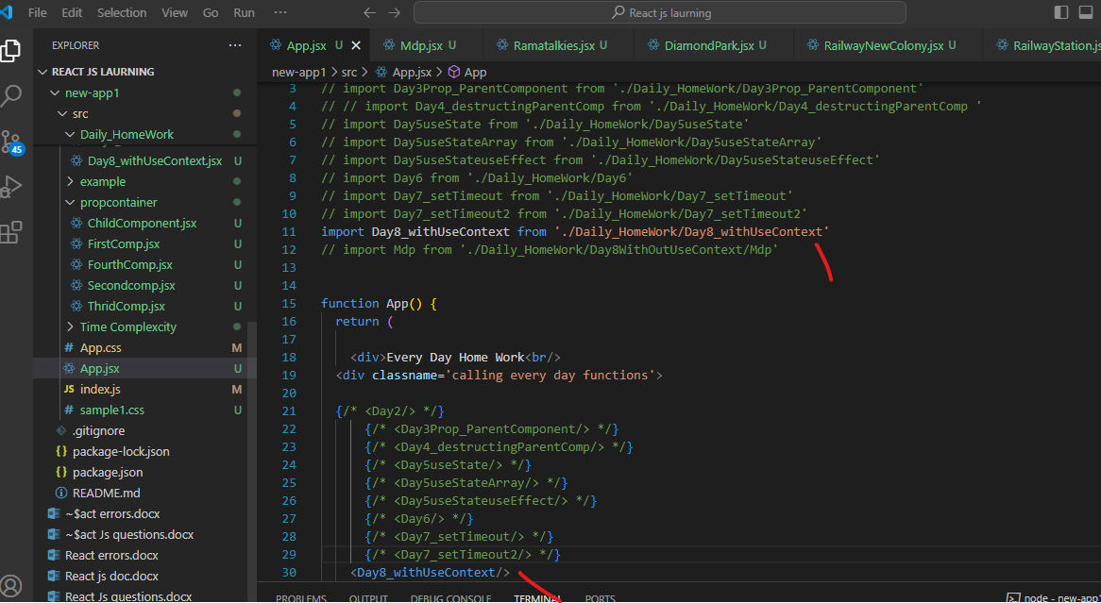

If two or more files import each other, it can cause this error. You should check the following files for circular dependencies:

To resolve this:

* Avoid importing components in a circular way.
* If **needed**, **move** shared **logic** to a **common** **file** and **import** **that** instead of the entire component.

Still you facing same issue

**OR**

**Possible Causes:**

1. **Circular Import Statements**:
   * Module **A** imports module **B**, and module B imports module **A**. This causes a loop where one module tries to use something before it's available.

Example:

// FileA.js

import FileB from './FileB';

// FileB.js

import FileA from './FileA';  // This creates a circular dependency